**Diverse lithic production strategies in southwest China during Late Middle Pleistocene**

**Authors:** Yue Hu1,2*, Ben Marwick3*, Hongliang Lu1, Yamei Hou4,5, Weiwen Huang4,5, Bo Li2,6

**Affiliations:**

1 School of Archaeology and Museology, Sichuan University, Chengdu 610207, China

2Centre for Archaeological Science, School of Earth and Environmental Sciences, University of Wollongong, Wollongong, NSW 2522, Australia

3Department of Anthropology, University of Washington, Seattle 98195, USA

4Key Laboratory of Vertebrate Evolution and Human Origins, Institute of Vertebrate Paleontology and Paleoanthropology, Chinese Academy of Sciences, Beijing 100044, China

5Institute of Vertebrate Paleontology and Paleoanthropology, Chinese Academy of Sciences, Beijing 100044, China

6ARC Centre of Excellence for Australian Biodiversity and Heritage, University of Wollongong, Wollongong, NSW 2522, Australia

*Correspondence to: YH ([yh280@scu.edu.cn](mailto:yh280@scu.edu.cn)), BM (bmarwick@uw.edu).

# **Abstract**

It has long been considered that there were no obvious lithic technological changes in East Asia during the Middle and Late Pleistocene until the appearance of Upper Palaeolithic forms in the Late Pleistocene. Here, we challenge this view with evidence of multiple Middle Palaeolithic lithic production systems appearing much earlier, from the Guanyindong site, southwest China, dated to 170–80 ka. Our analysis of the lithic assemblage reveals technological diversity in methods of core reduction and tool retouching. These methods include Levallois, discoid systems, core-on-flake, and volumetric methods, which were also commonly observed in west Eurasia contemporarily. The presence of a “pool of technological knowledge” reflects a mosaic package of multiple technological or strategical capability acquired by Late Middle Pleistocene populations in Guanyindong during this period. This ability clearly differs with what we observed in Early Palaeolithic as well as the notion of a long-lasting, static Middle Palaeolithic in East Asia.

# **Introduction**

The late Middle Pleistocene (LMP) witnessed the transition from Lower Palaeolithic to Middle Palaeolithic (MP) in west Eurasia and Africa (Early Stone Age to Middle Stone Age) and in many areas included significant milestones in human evolution, such as the replacement of *Homo erectus*/*Homo heidelbergensis* by *Homo sapiens* and other species 1-3. This transition was accompanied by the emergence and wide spread of Levallois strategies in Africa, Europe and Levant 4-6. Levallois lithic technology is often recognized as the hallmark of the MP 7,8. However, less visually striking shifts are also an important part of the MP technological complex 9. The shift to a variety of flake reduction systems and small tools made on flakes, replacing large cutting tools (LCTs) and core tools 10,11, is almost as indictive as the Levallois concept in symbolizing MP technological change. These technological systems reflect changes among MP hominins which indicate differences from their ancestors in, for example, cognitive, social and adaptive behaviors, demographic growth, and expansion of hunting and resource territories 10,12,13.

Recognition of these less visually striking technological changes is important to debates about distinctiveness of a ‘Middle Palaeolithic’ in East Asia, which has been controversial since the mid-20th century 14-16. Clearly Middle Palaeolithic technologies and cultures of East Asia and west Eurasia are different, more closely linked to differences in available raw material, ecological settings, population densities, individual ranges of technical knowledge, and so on 17,18. The interaction of these factors and the geographical factors that influence them are important for understanding differences in Pleistocene technologies in East Asia and west Eurasia. We present evidence here not only that impacts of these differences may have been overstated in previous work, but also that recognition of the less visually striking technological strategies of the MP can improve our understanding of global variation in Pleistocene lithic technologies.

To be specific, it is argued that there was a lack of distinct technological change (i.e., presence of the Levallois concept) in lithic technologies in East Asia since the Lower Palaeolithic period until relatively late in Upper Palaeolithic period 14, approximately 30 to 40 ka, which may be due to culturally modern humans migrating into these regions, bringing the new technologies with them 19. The lack of complex stone tool technologies in East Asia (i.e. the dominance of simple core and flake production systems) before MIS 3 has been interpreted as evidence that hominin populations in this region were culturally and genetically isolated during the early and middle Pleistocene 20. Biological evidence of *Homo sapiens* dating to the LMP and Late Pleistocene suggest that genetic isolation is no longer tenable although the arguments still go on 21-26. However, the archaeological evidence is not yet sufficient to reject the interpretation of cultural isolation. A recent discovery of Levallois technology from the Guanyindong site, southwest China, dated to ~170 to 80 ka 27 ignited debate by challenging this interpretation (**See SI section 2 for a summary of the debate**). The findings from Guanyindong suggest that the degree of stasis and isolation in the stone artefact technologies in East Asia during Middle and Late Pleistocene may have been overestimated. We present here the results of a systematic study of the lithic assemblage from Guanyindong, which further reveals the diverse lithic production strategies that signal the emergence of Middle Palaeolithic behaviors in contemporary East Asia.

Detailed description of the geological context and stratigraphy of Guanyindong has been provided in Li 28, Li 29, andHu, et al. 27. The artefact-bearing sediments from the west entrance were dated to between ~170 and ~80 ka 27. Here we report on the lithic technological strategies evident in the Guanyindong assemblage, based on our analysis of 2,211 artifacts from the west entrance (Table S1). Divergent phases were identified from the production processes of cores, flakes and retouched pieces, suggesting a complicated reduction system, including Levallois concept, multiple blank production strategies such as discoid, core-on-flake and volumetric production. Extensive supporting details of our technological analysis of the entire assemblage are presented in the Supplementary Information (SI).

# **Results**

## Levallois production

The systematics of Levallois lithic technology at Guanyindong was discussed previously 27. Here we extend this analysis with an investigation of the ‘standardization’ of Levallois flakes in the assemblage by comparing Levallois flakes and non-Levallois flakes. Levallois debitage systems are optimal in terms of raw material economics and flake utility since they increase the raw material’s efficiency and the length of ‘cutting edge’ that can be created from a given blank 30,31. In other words, Levallois flakes exhibit a greater standardization in their attributes compared with the ‘non-preferred’ flakes. In order to test this, we compared the coefficient of variation (CV) of Levallois and complete flakes (including retouched complete flakes) on the base of several essential attributes (Table 1). We found that the CV values of Levallois flakes are substantially smaller than those of complete flakes (Mann-Whitney W = 61; p = 0.033), supporting previous finds that Levallois flakes are more standardized than other complete flakes 30. We found that mass and metric dimensions are similar between Levallois and non-Levallois, but Levallois flakes are thinner than non-Levallois flakes (Figure 1A-C). We might infer that the Levallois strategy was employed at Guanyindong to reliably produce thinner flakes. Although the results of our comparison shows that Levallois flakes are statistically distinctive, concluding definitively whether they were ‘preferred’ would benefit from further analysis, e.g., usewear and residue analysis, and refitting (unfortunately not currently possible with this assemblage).

## Discoid Production

Discoid debitage 32 has been found in many sites and shows substantial variability 33. This can be contrasted with the Levallois strategy where the two surfaces are hierarchically related and cannot be reversed and their roles cannot be exchanged. The use of the discoid method in Guanyindong is indicated by ten discoid cores (see examples in Figure 2) and diversified products that are potentially pertinent to this system, such as triangles, and short thick flakes as well as pseudo-Levallois points. (Figure 2 and SI Figure S4).

Two types of discoidal cores are identified in Guanyindong. One can fit in the definition of Boëda 32 that have two exchangeable surfaces serving as both flaking or striking surface (**Figure 2**a-c). another discoidal exploitation is featured by one surface remaining flat as a striking platform, and the other surface working as flaking surface formed by centripetal scars which extend to the distal end (**Figure 2**d). In Guanyindong, the later type is more common which might trace back to Lower Palaeolithic technologies. Chert is the main raw material (>90%) utilized at Guanyindong. Core sizes are moderate. around 70 mm long and the average mass is about 160g. According to the major scars left on the working surface, those cores usually yield 4-6 successive flakes. More than half of them have partial cortex (the cortex covers mostly 10%, but 50% area on some extreme specimen) remaining on the platforms or distal places, probably as a result of local or early stage of manufacture. Platforms were rarely prepared.

A variety of end-products/by-products of discoid production are found in the Guanyindong assemblage including pseudo-Levallois points, short débordant flakes, triangular and quadrangular flakes (see example in Figure 2e-g). Among those products, Pseudo-Levallois points and débordant flakes appeared in small quantities. Because both centripetal recurrent Levallois methods and discoid production can be responsible for these kinds of flakes, it is hard to separate those byproducts from either of the two production systems. Other than by-products, a large number of triangular flakes (unfortunately, we cannot rule out the possibilities of that other systems that can also produce triangular flakes), most of which were retouched into tools (further details on retouch are available in the SI), less directly implies the usage of discoid production at Guanyindong.

Despite the fact that the manufacture of discoid methods involves a relatively a low degree of predetermination, compared to Levallois strategies, the relatively high productivity (since it does not need re-preparation between each reduction phase) and lower requirement for technological investment 34,35, may reflect the requirements (to obtain short, thick and ‘pointed’-trangular flakes) and capacity of knappers at Guanyindong to make foraging plans that anticipate their tooling needs in a high-mobility land use strategy. The highly mobile subsistence strategy is also reflected by the relatively small number of discoid cores and large number of flakes potentially from discoid cores, as well as the high ratio of those transformed into tools.

## Quina exploitation

Quina exploitation is the least conspicuous reduction scheme among those production strategies in Guanyindong. The most direct evidence come from seventy Quina sidescrapers and Quina resharpening flakes at the site (Figure 3a-e). The retouching scars on these tools form a distinctive stepped morphology, especially where those scars overlapped on the retouched edge 36. These tools were probably produced to meet multiple functional requirements such as treating various organic materials including both animal (hides, meat) and plants (wood) 37,38. For example, by blunting the edge, knappers made the edges less efficient when processing hides 39. Frequent resharpening and recycling to extend the use-life of tools are probably another explanation for the presence of Quina at Guanyindong.

Other observations from the assemblage that imply the probable usage of Quina exploitation include: (1) the prevailing steep edges, the median retouched edge angle of the assemblage is nearly 70° (**Figure 1D-F**, also see discussion in **SI**); (2) relatively thick blanks that provide high retouch potential (the average ratio of oriented width to oriented thickness = 3.1 (sd = 1.06), and the mean thickness = 17.9mm (sd = 8.69), **Figure 3f**); and (3) the presence of several retouching phases on artefacts (see discussion in **SI**). The combination of those traits are regarded as indictive features of Quina scheme 37.

Although there are debates about whether Quina retouch was deliberately produced or whether it was the result of resharpening thick blanks unintentionally, the presence of Quina artefacts at Guanyindong indicates intensive retouching activity on long-lived tools, which is relevant to understanding mobility patterns of the hominin occupants of the site. In Europe, Quina products were frequently found with seasonally migrating fauna 40. This association, together with several successive retouching phases on the same edge, is often interpreted as indicating a higher level of mobility and regular long-distance travel. In the case of Guanyindong, abundant fossils fragments of big games 27,28 that subjected to ecological changes were recovered associated with stone tools . If this is also the case at Guanyindong, it indicates a high mobile pattern Guanyindong population equipped to cope with the environmental and substantial conditions changes. This adaptive capacity reflects the plasticity of the hominins activities in this region during the LMP.

## Core-on-flake

At Guanyindong, core-on-flake strategies are mainly presented by both truncated-faceted pieces (flakes with a truncation, on one or more margins, that was used as a platform for the removal of one or more small flakes from the exterior surface. The consequent final morphology is a core with flake scars on the ventral surface, indicating the production of invasive periphery flakes from platforms along the flake’s dorsal edge) and Kombewa flakes (when the ventral surface of a flake was used as a flake-release surface, and the resulting flake may can appear to have two ventral faces). Truncated-facetted pieces have been frequently identified under different names through the Middle to Upper Paleolithic in Africa, Europe, Levant and north Asia 41-43. It is sometimes regarded as a response to lithic raw material scarcity and to high mobility of forager groups 44.

The likely functions of truncated faceted pieces are disputed. Some believe they are a type of prepared core 45, while others primarily regard them as tools 42 or "specific oriented products" 46, or thinning for hafting as phrased by Schroeder 43. In the case of Guanyindong, either working as a core or producing a particular working edge is plausible, subject to the requirements of different scenarios. Other truncated facets bearing relatively large ventral flake scars and irregular edges suggest they are more inclined to been utilized as cores (see examples in **Figure 4a, c and e** and **SI Figure S4**), though we expect the function varied as needed. The average dimension and mass are 76 mm and 135 g respectively, which are consistent with the data of general cores in the site (75 mm and 175 g). The raw material was dominated by chert (80%), followed by limestone. The exploitation of flakes as blanks for the truncated faceted technique may be evidence of a predetermination concept, since this strategy requires multi-stage production, indicating advance planning.

Another important type of core-on-flake flaking found in Guanyindong is the Kombewa flakes and cores (Figure 4d, h, f-g). We found 21 Kombewa flakes (median maximum dimension = 69 mm), and 10 Kombewa cores (median maximum dimension = 82.4 mm), most of which show truncated faceting also. Kombewa production is well known in Africa, but has also been found in many lithic industries around Eurasia see 47,48. During the Early Stone Age, the Kombewa technique is mainly used in the Acheulean assemblages from Africa and Europe before the development of Levallois strategies 49. At Guanyindong, the Kombewa method was utilized to produce relatively small flakes with sharp edges.

## Volumetric exploitation

Cores presenting a volumetric exploitation (e.g. pyramidal, prismatic, etc. geometries, where the striking platform is prepared but the convexities are not prepared and only the natural convexities of the raw block are used; These cores utilize the volume of the core rather than one surface50) appeared in a small quantity (n = 12, see examples in **Figure 5 and SI Figure S4**). Almost half of their striking platforms were parsimoniously prepared. Reduction was by direct hard hammer, and most cores have no cortex. Those preparations are clearly demonstrated through successive small removals on the striking part, leaving the remainder of the surface nearly untouched (cortical or minimally prepared). Other preparations come from the maintain of core volume by centralizing the working surface through detachment of rear lateral removals 50. The selection of blanks was intentionally focused on columnar nodules or chunks with one flat surface. The flat surface, thus, could potentially serve as a striking platform. The sizes of these cores are consistently smaller (around 50 mm, p=0.00033) than general cores (see SI), with no cores found larger than 100 mm.

However, very few by-products (n = 11) related to this reduction have been found in the system. This may due to the transportation of end-products outside of the site, or the importation of the cores from elsewhere, since frequent mobility seems to be one of the distinctive strategies of the site.

# **Discussion**

The variability of LMP lithic technology in East Asia was clearly more complex than the classificatory schemes in current use for lithic systematics in this region. The technical knowledge evident at Guanyindong may initially have arisen among the small groups of hominins that implemented techno-cultural diversity as they repeatedly occupied the cave during the LMP 51. The various technological systems were entangled internally, such like the flakes produced by a discoid system, can be transferred into a core-on-flake system 52. The by-products and end-products of these strategies were also likely intertwined, rather than discrete, unrelated sequences. This kind of lithic production may be considered as a ‘fluid behavioral set’ that is influenced by technique, raw material and environment 53. This perplexity is broadly documented in many sites, especially in Europe, and described as a ‘fragmented character’ 54. We propose this concept may be relevant to understanding the Guanyindong hominins also. The selection of knapping manufacture and maintenance procedures for tools in the MP industry at Guanyindong was contingent on numerous factors, including raw materials, on-site activities, mobility, and the environment. All of these factors contributed to the diverse circumstances in which stone artefacts were made and used at Guanyindong.

The Guanyindong assemblage is chronologically associated with the Marine Isotopic Stages 6 and 5. This means that the MP hominins in Guanyindong cave have experienced at least one significant climate transition from a glacial period (MIS 6) of cooler temperatures to a warmer interglacial condition (MIS 5). These climate fluctuations and environmental changes likely stimulated hominins to alternate among a variety of tool-making strategies as they explored the space of technological strategies to find optima for new and unfamiliar conditions. During harsher periods we infer that people maintained a supply of tools by foraging in larger territories, which resulted in multi-purpose and long-life tools or easily transformed artifacts, such as discoid/Quina production 40,but also see 55. Another response to these harsher periods were Levallois strategies that are adapted to a variety of hunting strategies in dynamics environments 56.

If we leave out the by-products and end-products and only take cores into account, they account for a relatively small proportion of the whole assemblage (17%, and including truncated faceted pieces, the percentage is ~40%, see details in **SI**). The small proportion cannot be easily interpreted, but indicates high fragmentation of lithic reduction across time and space. This segmentation could be attributable to the inherent flexibility and mobility of the MP which is embedded in lithic technologies 54. In the case of Guanyindong, the products of reduction sequences are even more diffuse relative to the western hemisphere. Equal with the mechanism underlying the paucity of the Levallois concept at Guanyindong, the rarity of material traces may have been due to the narrower ranges of technological strategies adopted by fragmented populations, compared to the relative high population and/or high-density conditions of Middle Pleistocene in west Eurasia. Consequently, the weak and/or irregular patterns of social interconnectedness due to small population sizes and densities may have impeded the spread and establishment of technological innovations 51.

An important limitation to the implications of our analysis of the Guanyindong assemblage is the scarcity of artefact provenance data in the excavation records. Our previous work established that artefacts were produced in two discrete periods, one clustered at around 170 ka (MIS 6) and the other clustered at 80 ka (MIS 5). The large chronological gap (~80-90 ka) between the two periods is due to an erosional hiatus in the deposits. The field recording methods employed in the initial excavation mean that we cannot confidently allocate the artefacts to a specific time period. Unfortunately, future excavations at Guanyindong are unlikely to resolve this as most of the cultural deposit was removed by the previous excavators. This also limits our ability to make robust claims about change over time, though our previous analysis indicate that the technological attributes show little difference between the upper and lower layers see SI from 27. Hence, the diversity described here, for example, on one hand, could either represent coexistence of multiple technological strategies in a certain time or, on the other hand, a sequence of technological changes over time, similar to that widely observed at sites in west Eurasia 18.

In contrast to the fine-grained behavioural evidence and high-resolution technological studies from a wide range of MP sites in West Eurasia, the data from East Asia are sparse and reports are typically coarse-grained. To date, many paleolithic sites in southwest China have been found 57-61, though only a few of them, such as Guanyindong and Panxiandadong 62, have been reliably dated to the LMP period. Evidence of various traits of MP technologies in Guanyindong, such as Levallois strategies, multiple blank production techniques including discoid and core-on-flake, and various methods on tool manufacture and management such like Quina-like systems, would just be ‘a tip of iceberg’ of technological abilities hominins in this area had during MIS 6 – 5 that are comparable as those in west Eurasia and Africa and are still waiting to reveal.

In sum, our paper demonstrates the diversity of MP in East Asia for the first time, indicating that the appearance of Levallois concept in Guanyindong is not an ‘isolated’ or ‘odd’ technological strategy at this location. On the contrary, the Guanyindong hominins developed many complex elements of MP tool-kits to cope with their daily routines, challenging the longstanding view of long-term simplicity in lithic technology during the Early and Middle Palaeolithic periods in East Asia. The absence of human fossils dated to the same period in southwest China, hampers speculation about the hominin species that produced the Guanyindong Cave assemblage. However, accumulated anthropological studies in and/or near this region have shed the light on the probable hominin taxa. The Denisovan fossil found in Baishiya, dated 160ka, provides the first evidence of Denisovan territories in East Asia 22. The appearance of modern humans 21,26,63, and shared morphology with the Neandertals found on crania from Xuchang 64 suggest that the identity of the hominins that lived here is more complex and interlaced than we previously thought.

The limited number of available assemblages for the Palaeolithic in the Eastern hemisphere does not at present allow robust clarification of relationships among technical behaviors and resolution of the debate on where and when the common technological ancestor for East Asian and Western MP may be found, and what circumstances lead to the appearance of MP technologies in East Asia (e.g. direct descent from a common technological ancestor or recent convergent technological evolution after substantial divergence). A key challenge for future research on other LMP sites in this region is to establish more detailed pattern and timing of the MP production and specifically evaluate models of technological convergence or transmission.

# **Methods**

Based on the technical analyses developed by authors such as Geneste 65, Boëda et al. 32,66, Geneste et al. 67 and Vaquero 68, the whole lithic assemblage was fully studied to record both qualitative and quantitative parameters. The qualitative method follows the general concepts of the chaîne opératoire 69-72. The process includes the recognition of the raw material; the reduction strategies of cores; and the retouched flake tool types, shaped tools, 73,74 or unretouched products (flakes, flake fragments, debris and chunks). The quantitative analysis was mainly based on metrical and morphometric data including basic statistics on artifacts dimensions and main attributes. For the chunks and debris, only mass was measured.

The recognition of Levallois products from Levallois system is harder compared with the identification of cores 75-77. Unfortunately, the recognition of Levallois flakes is not based on refitting analysis due to the insufficiency of specimens. However, several criteria were taken into consider to avoid arbitrariness. Those criteria include a clearly organized scar pattern 73 which indicates the predetermined process, and the angles between the striking platform and debitage surfaces to monitor the percussion angle of the flake, morphological symmetry was also considered 73.

In terms of discoid production, the definition developed by Boëda 32,75 is taken into account here as well as broader criteria 78. The Quina exploitation is identified according to the widely accepted definition of Quina debitage by Bourguignon 79 and the interpretations of subsequent scholars 37. The core-on-flake consist of two main categories: truncated-faceted and Kombewa debitage. Truncated-faceted has been studied and discussed in a wide range in many reports 11,45,80. Based on the general principles of those reports, we ascribe the truncated-faceted preliminarily to flakes that were truncated first and then removals (larger than 10 mm) were detached mostly, but not always, on the ventral surface. The term of Kombewa in the study is referring to a wider meaning rather than Kombewa *stricto sensu* 81. The recognition of Kombewa method is associated with two bulbar residuals on the proximal end of both the ventral and dorsal surfaces of a flake. Correspondingly, the cores produced these flakes are actually flakes with a pronounced bulb having another flake detached from it, rather than a core nodule (Kombewa flake). Our diagnosis of volumetric exploitation used the volumetric concept for reference and analytical approach described by Carmignani 50.

# **References**

1 Hublin, J.-J. *et al.* New fossils from Jebel Irhoud, Morocco and the pan-African origin of Homo sapiens. *Nature* **546**, 289-292, doi:10.1038/nature22336 (2017).

2 Harvati, K. *et al.* Apidima Cave fossils provide earliest evidence of Homo sapiens in Eurasia. *Nature* **571**, 500-504, doi:10.1038/s41586-019-1376-z (2019).

3 Jacobs, Z. *et al.* Timing of archaic hominin occupation of Denisova Cave in southern Siberia. *Nature* **565**, 594-599, doi:10.1038/s41586-018-0843-2 (2019).

4 Tryon, C. A., McBrearty, S. & Texier, P.-J. Levallois Lithic Technology from the Kapthurin Formation, Kenya: Acheulian Origin and Middle Stone Age Diversity. *African Archaeological Review* **22**, 199-229, doi:10.1007/s10437-006-9002-5 (2005).

5 Fontana, F. *et al.* Widespread diffusion of technical innovations around 300,000 years ago in Europe as a reflection of anthropological and social transformations? New comparative data from the western Mediterranean sites of Orgnac (France) and Cave dall’Olio (Italy). *Journal of Anthropological Archaeology* **32**, 478-498, doi:<https://doi.org/10.1016/j.jaa.2013.08.003> (2013).

6 Goren-Inbar, N. in *Continuity and Discontinuity in the Peopling of Europe: One Hundred Fifty Years of Neanderthal Study* (eds Silvana Condemi & Gerd-Christian Weniger) 89-100 (Springer Netherlands, 2011).

7 McBrearty, S. & Brooks, A. S. The revolution that wasn't: a new interpretation of the origin of modern human behavior. *Journal of Human Evolution* **39**, 453-563, doi:<https://doi.org/10.1006/jhev.2000.0435> (2000).

8 Monnier, G. The Lower/Middle Paleolithic Periodization in Western Europe An Evaluation. *Current Anthropology* **47**, 709-744, doi:10.1086/506280 (2006).

9 Tryon, C. A. & Faith, J. T. Variability in the Middle Stone Age of Eastern Africa. *Current Anthropology* **54**, S234-S254, doi:10.1086/673752 (2013).

10 Kuhn, S. L. Roots of the Middle Paleolithic in Eurasia. *Current Anthropology* **54**, S255-S268, doi:10.1086/673529 (2013).

11 Dibble, H. & McPherron, S. The Missing Mousterian. *Current Anthropology* **47**, 777-803, doi:10.1086/506282 (2006).

12 Berna, F. & Goldberg, P. *Assessing Paleolithic pyrotechnology and associated hominin behavior in Israel*. Vol. 56 (2007).

13 Shennan, S. Demography and Cultural Innovation: a Model and its Implications for the Emergence of Modern Human Culture. *Cambridge Archaeological Journal* **11**, 5-16 (2001).

14 Gao, X. & Norton, C. J. A critique of the Chinese 'Middle Palaeolithic'. *Antiquity* **76**, 397-412 (2002).

15 Kei, Y. M. The Middle Palaeolithic in China a review of current interpretations. *Antiquity* **86**, 619-626, doi:10.1017/S0003598X00047803 (2012).

16 Lycett, S. J. & Bae, C. J. The Movius Line controversy: the state of the debate. *World Archaeol.* **42**, 521-544 (2010).

17 Rolland, N. & Dibble, H. L. A New Synthesis of Middle Paleolithic Variability. *American Antiquity* **55**, 480-499 (1990).

18 Delagnes, A. & Meignen, L. in *Transitions Before the Transition: Evolution and Stability in the Middle Paleolithic and Middle Stone Age* (eds Erella Hovers & Steven L. Kuhn) 85-107 (Springer US, 2006).

19 Bae, C. J., Douka, K. & Petraglia, M. D. On the origin of modern humans: Asian perspectives. *Science* **358**, eaai9067, doi:10.1126/science.aai9067 (2017).

20 Wang, Y. Late Pleistocene Human Migrations in China. *Current Anthropology* **58**, S504-S513, doi:10.1086/693899 (2017).

21 Liu, W. *et al.* The earliest unequivocally modern humans in southern China. *Nature* **526**, 696-699, doi:10.1038/nature15696 (2015).

22 Chen, F. *et al.* A late Middle Pleistocene Denisovan mandible from the Tibetan Plateau. *Nature* **569**, 409-412, doi:10.1038/s41586-019-1139-x (2019).

23 Sun, X.-f. *et al.* Ancient DNA and multimethod dating confirm the late arrival of anatomically modern humans in southern China. *Proceedings of the National Academy of Sciences* **118**, e2019158118, doi:10.1073/pnas.2019158118 (2021).

24 Curnoe, D. *et al.* Reply to Martinón-Torres et al. and Higham and Douka: Refusal to acknowledge dating complexities of Fuyan Cave strengthens our case. *Proceedings of the National Academy of Sciences* **118**, e2104818118, doi:10.1073/pnas.2104818118 (2021).

25 Martinón-Torres, M. *et al.* On the misidentification and unreliable context of the new “human teeth” from Fuyan Cave (China). *Proceedings of the National Academy of Sciences* **118**, e2102961118, doi:10.1073/pnas.2102961118 (2021).

26 Bae, C. J. *et al.* Modern human teeth from Late Pleistocene Luna Cave (Guangxi, China). *Quaternary International* **354**, 169-183, doi:<https://doi.org/10.1016/j.quaint.2014.06.051> (2014).

27 Hu, Y. *et al.* Late Middle Pleistocene Levallois stone-tool technology in southwest China. *Nature* **565**, 82-85, doi:10.1038/s41586-018-0710-1 (2019).

28 Li, Y., Wen, B. Guanyindong: A Lower Paleolithic Site at Qianxi County, Guizhou Province. 1–181 (1986).

29 Li, Y. *Technological study of lithic industry of the Guanyindong site, Guizhou Province, south-west of China* Ph.D thesis, (2009).

30 Lycett, S. J. & Eren, M. I. Levallois economics: an examination of 'waste' production in experimentally produced Levallois reduction sequences. *Journal of Archaeological Science* **40**, 2384-2392, doi:10.1016/j.jas.2013.01.016 (2013).

31 Brantingham, P. J. & Kuhn, S. L. Constraints on Levallois Core Technology: A Mathematical Model. *Journal of Archaeological Science* **28**, 747-761, doi:<https://doi.org/10.1006/jasc.2000.0594> (2001).

32 Boëda, E. Le débitage discoïde et le débitage Levallois récurrent centripède. *Bulletin de la Société préhistorique française* **90**, 392-404 (1993).

33 Pasty, J.-F. Le gisement Paléolithique moyen de Meillers (Allier) : un exemple de la variabilité du débitage Discoïde. *Bulletin de la Société préhistorique française* **97**, 165-190 (2000).

34 Delpiano, D. & Peresani, M. Exploring Neanderthal skills and lithic economy. The implication of a refitted Discoid reduction sequence reconstructed using 3D virtual analysis. *Comptes Rendus Palevol* **16**, 865-877, doi:<https://doi.org/10.1016/j.crpv.2017.06.008> (2017).

35 Picin, A. & Vaquero, M. Flake productivity in the Levallois recurrent centripetal and discoid technologies: New insights from experimental and archaeological lithic series. *Journal of Archaeological Science: Reports* **8**, 70-81, doi:<https://doi.org/10.1016/j.jasrep.2016.05.062> (2016).

36 Agam, A. & Zupancich, A. Interpreting the Quina and demi-Quina scrapers from Acheulo-Yabrudian Qesem Cave, Israel: Results of raw materials and functional analyses. *J. Hum. Evol.* **144**, 102798, doi:<https://doi.org/10.1016/j.jhevol.2020.102798> (2020).

37 Hiscock, P., Turq, A., Faivre, J. P. & Bourguignon, L. in *Lithic Materials and Paleolithic Societies* (eds B. Adams & B.S. Blades) 232-246 (2009).

38 Hardy, B. L. Neanderthal behaviour and stone tool function at the Middle Palaeolithic site of La Quina, France. *Antiquity* **78**, 547-565, doi:10.1017/S0003598X00113213 (2004).

39 Preysler, J. in *Experiments and Interpretation of Traditional Technologies: Essays in Honor of Errett Callahan* (ed Hugo G. Nami) 171-202 (Arqueolog ía Contemporánea, 2010).

40 Delagnes, A. & Rendu, W. Shifts in Neandertal mobility, technology and subsistence strategies in western France. *Journal of Archaeological Science* **38**, 1771-1783, doi:<https://doi.org/10.1016/j.jas.2011.04.007> (2011).

41 Hovers, E. in *Cores or Tools? Alternative Approaches to Stone Tool Analysis* (ed S.P. McPherron) 42-74 (Cambridge Scholars Press, 2007).

42 Shalagina, A. V., Krivoshapkin, A. I. & Kolobova, K. A. TRUNCATED-FACETED PIECES IN THE PALEOLITHIC OF NORTHERN ASIA. *Archaeology, Ethnology and Anthropology of Eurasia* **43**, 33-45, doi:<https://doi.org/10.1016/j.aeae.2016.02.004> (2015).

43 Schroeder, B. Truncated-faceted pieces from Jerf Al-Ajla. *Tools Versus Cores. Alternative Approaces to Stone Tool Analysis*, 17-41 (2007).

44 Wallace, I. J. & Shea, J. J. Mobility patterns and core technologies in the Middle Paleolithic of the Levant. *Journal of Archaeological Science* **33**, 1293-1309, doi:<https://doi.org/10.1016/j.jas.2006.01.005> (2006).

45 Brantingham, P. J., Olsen, J. W., Rech, J. A. & Krivoshapkin, A. I. Raw Material Quality and Prepared Core Technologies in Northeast Asia. *Journal of Archaeological Science* **27**, 255-271 (2000).

46 Dibble, H. The Mousterian Industry from Bisitun Cave (Iran). *Paleorient* **10** (1984).

47 Boëda, E. & Au Présent, P. *Techno-logique & Technologie Une Paléo-histoire des objets lithiques tranchants*. (2018).

48 J. Wang, F. H. T., Y.R. Wang. The report of excavation and survey at the Dingcun Site. *Journal of Chinese Antiquity*, 1-75 (1994).

49 Inizan, M.-L., Reduron-Ballinger, M., Roche, H., Tixier, J.,. *Technology and Terminology of Knapped Stone*. (CREP, Nanterre, 1999).

50 Carmignani, L., Moncel, M.-H., Fernandes, P. & Wilson, L. Technological variability during the Early Middle Palaeolithic in Western Europe. Reduction systems and predetermined products at the Bau de l'Aubesier and Payre (South-East France). *PLOS ONE* **12**, e0178550, doi:10.1371/journal.pone.0178550 (2017).

51 Lycett, S. J. & Norton, C. J. A demographic model for Palaeolithic technological evolution: The case of East Asia and the Movius Line. *Quaternary International* **211**, 55-65, doi:<http://dx.doi.org/10.1016/j.quaint.2008.12.001> (2010).

52 Faivre, J. P. L’industrie lithique moustérienne du niveau G7 des Fieux (Miers, Lot): des matériaux, des schémas opératoires, un même objectif. *Paléo* **16**, 71-90 (2004).

53 Shott, M. J., Lindly, J. & Clark, G. A. Special issue: reduction sequence, chaîne opératoire, and other methods: the epistemologies of different approaches to lithic analysis. Continuous modeling of core reduction: lessons from refitting cores from WHS 623x, an Upper Paleolithic site in Jordan. *PaleoAnthropology* **11**, 320-330 (2011).

54 Turq, A., Roebroeks, W., Bourguignon, L. & Faivre, J.-P. The fragmented character of Middle Palaeolithic stone tool technology. *J. Hum. Evol.* **65**, 641-655, doi:<https://doi.org/10.1016/j.jhevol.2013.07.014> (2013).

55 Thiébaut, C. Discoid debitage stricto sensus: a method adapted to highly mobile Middle Paleolithic groups? *Palethnologie*, 4-20, doi:10.4000/palethnologie.580 (2013).

56 White, M. J. & Pettitt, P. B. Technology of early Palaeolithic western Europe: innovation, variability and a unified framework. *Lithics* **16**, 27-40 (1995).

57 Cai, H. W., Xinjin.; Xu, Chunhua. Paleolith of Bianbian cave at Bijie county, Guizhou province. *Acta Anthropologica Sinica* **10**, 50-57 (1991).

58 Wu, M. W. L. Z., Yinyun; Zhang, Senshui. Ancient Human fossils and cultural remains in Tongzi, Guizhou Province. *Vertebrata Palasiatica* **13**, 14-23 (1975).

59 Cao, Z. Palaeolithic site found in Xiaohuidong cave at Shuicheng, Guizhou Province. *Vertebrata Palasiatica* **16**, 67-72 (1978).

60 Zhu, Z. J., Xueping. Study on the Stone Artifacts From the Laohu Cave Paleolithic Site , Baoshan County, Yunnan *Research of China's frontier archaeology* **4** (2011).

61 Hu, Y., Ruan, Q., Liu, J., Marwick, B. & Li, B. Luminescence chronology and lithic technology of Tianhuadong Cave, an early Upper Pleistocene Paleolithic site in southwest China. *Quat. Res. (USA)* **94**, 121-136, doi:10.1017/qua.2019.67 (2019).

62 Zhang, J. F., Huang, W. W., Hu, Y., Yang, S. X. & Zhou, L. P. Optical dating of flowstone and silty carbonate-rich sediments from Panxian Dadong Cave, Guizhou, southwestern China. *Quaternary Geochronology* **30**, 479-486, doi:10.1016/j.quageo.2015.01.011 (2015).

63 Liu, W., Wu, X., Guan, Y., Wu, x. j. & J. Norton, C. *Huanglong Cave: A Late Pleistocene human fossil site in Hubei Province, China*. Vol. 211 (2010).

64 Li, Z.-Y. *et al.* Late Pleistocene archaic human crania from Xuchang, China. *Science* **355**, 969, doi:10.1126/science.aal2482 (2017).

65 Geneste, J.-M. in *L’Homme de Néandertal* Vol. 8 (ed M. Otte) 61-70 (1988).

66 Eric Boëda, J.-M. G., Liliane Meignen. Identification de chaînes opératoires lithiques du Paléolithique ancien et moyen. *Paléo* **2**, 43-80 (1990).

67 Geneste, J.-M., Jaubert, J., Lenoir, M., Meignen, L. & Turq, A. Approche technologique des Moustériens charentiens du sud-ouest de la France et du Languedoc oriental. *Paleo* **9**, 101-142 (1997).

68 Vaquero, M. The history of stones: behavioural inferences and temporal resolution of an archaeological assemblage from the Middle Palaeolithic. *Journal of Archaeological Science* **35**, 3178-3185, doi:<https://doi.org/10.1016/j.jas.2008.07.006> (2008).

69 Bar‐Yosef, O. & Van Peer, P. The Chaîne Opératoire Approach in Middle Paleolithic Archaeology. *Current Anthropology* **50**, 103-131, doi:10.1086/592234 (2009).

70 Sellet, F. Chaine Operatoire; The Concept and Its Applications. *Lithic Technology* **18**, 106-112, doi:10.1080/01977261.1993.11720900 (1993).

71 Pelegrin, J., Karlin, C. & Bodu, P. in *Journee d 'Etudes Technologiques en Prehistoire* (ed J. Tixier) 55-62 (CNRS, 1988).

72 Geneste, J.-M. Systèmes techniques de production lithique: variations techno-e ´conomiques dans les processus de re ´alisation des outillages pale ´olithiques. *Techniques et culture* **17-18**, 1-35 (1991).

73 Debénath, A. & Dibble, H. L. *Handbook of Paleolithic Typology: Lower and Middle Paleolithic of Europe*. (University of Pennsylvania Press, 1993).

74 Bordes, F. *Typologie du Paléolithique Ancien et Moyen*. (Centre National de la Recherche Scientifique, 1961).

75 Boëda, E. in *The Definition and Interpretation of Levallois Technology* (eds Harold Dibble & Ofer Bar-Yosef) 41–68 (Prehistory Press, 1995).

76 Van Peer, P. *The Levallois Reduction Strategy*. (Prehistory Press, 1992).

77 Shimelmitz, R. & Kuhn, S. Early Mousterian Levallois technology in Unit IX of Tabun Cave. *Paleoanthropology* **2013**, 1-27, doi:10.4207/PA.2013.ART77 (2013).

78 Peresani, M. La variabilité du débitage discoïde dans la grotte de Fumane (Italie du Nord)/The variability of discoid production at the grotte de Fumane *Paléo* **10**, 123-146 (1998).

79 Bourguignon, L. La conception de debitage quina. *Quaternaria Nova* **VI**, 149-166 (1996).

80 Marwick, B., Clarkson, C., O'Connor, S. & Collins, S. Early modern human lithic technology from Jerimalai, East Timor. *J. Hum. Evol.* **101**, 45-64, doi:<http://dx.doi.org/10.1016/j.jhevol.2016.09.004> (2016).

81 Tixier, J. & Turq, A. Kombewa et alii. *Paléo* **11**, 135-143 (1999).

# **Acknowledgments**

Thank Sam Lin for advice on lithic analysis. Also thank Ning Ma, Yushan Lou, Jianping Yue and Lei Lei for their assistances during the research in IVPP. This work was supported by the Australian Research Council through Future Fellowships to B.L. (FT140100384) and B.M. (FT140100101). National Science Foundation of China (NO. 42002201) and Postgraduate scholarships from the University of Wollongongto Y.H., the Chinese Academy of Science (CAS) Strategic Priority Research Program Grants of “Macroevolutionary Processes and Paleoenvironments of Major Historical Biota” (No. XDPB05), State Key Laboratory of Loess and Quaternary Geology, Institute of Earth Environment, CAS (No. SKLLQG1501) and National Science Foundation of China (No. 41272033) to Y.-M.H.

# **Author contributions**

B.L., Y.H., and W.-W.H. conceived and coordinated the study. Y.H., B.L. and Y.-M.H. conducted the fieldwork. Y.H., B.M., Y.-M.H., and H.-L.L. conducted the stone artefact analysis. Y.H., B.M., and H.-L.L. wrote the manuscript, with contributions from the other authors.

# **Competing interests**

Authors declare that they have no competing interests.

# **Materials & Correspondence**

Requests for materials should be addressed to Y. H. or B. M.

# **Supplementary information**

--Lithic technological analysis

--Controversy of Levallois concept at Guanyindong

--Data collection method

--Reference

|  |  |  |  |  |  |  |  |
| --- | --- | --- | --- | --- | --- | --- | --- |
| **Table 1 | Results of descriptive statistics for Levallois and non-Levallois flakes.** ‘PLF’ stands for preferential Levallois flake; ‘CF’ stands for complete flake. | Mean (mm) | | SD | | CV (%) | | |
| PLF | CF | **PLF** | CF | PLF | CF | Difference |
| Length | 47.43 | 49.12 | 18.42 | 19.93 | 38.83 | 40.57 | -1.74 |
| Max dimension | 55.96 | 62.73 | 20.25 | 24.47 | 36.18 | 39.00 | -2.82 |
| Oriented width | 46.90 | 50.29 | 17.91 | 21.02 | 38.18 | 41.79 | -3.61 |
| Width at 25% max | 32.40 | 36.06 | 12.40 | 14.59 | 38.27 | 40.47 | -2.20 |
| Width at 50% max | 37.13 | 41.66 | 13.37 | 16.74 | 35.99 | 40.18 | -4.18 |
| Width at 75% max | 30.60 | 34.96 | 12.49 | 15.88 | 40.82 | 45.42 | -4.60 |
| Oriented thickness | 12.16 | 17.88 | 4.45 | 9.02 | 36.64 | 50.46 | -13.82 |
| Thickness at 25% max | 11.05 | 16.10 | 4.44 | 8.14 | 40.20 | 50.55 | -10.35 |
| Thickness at 50% max | 11.95 | 17.07 | 4.78 | 8.68 | 40.01 | 50.87 | -10.86 |
| Thickness at 75% max | 10.04 | 14.24 | 4.29 | 7.68 | 42.74 | 53.93 | -11.19 |
| Platform width | 31.69 | 33.46 | 16.38 | 18.28 | 51.68 | 54.64 | -2.95 |
| Platform thickness | 10.98 | 13.30 | 4.66 | 8.07 | 42.46 | 60.67 | -18.21 |

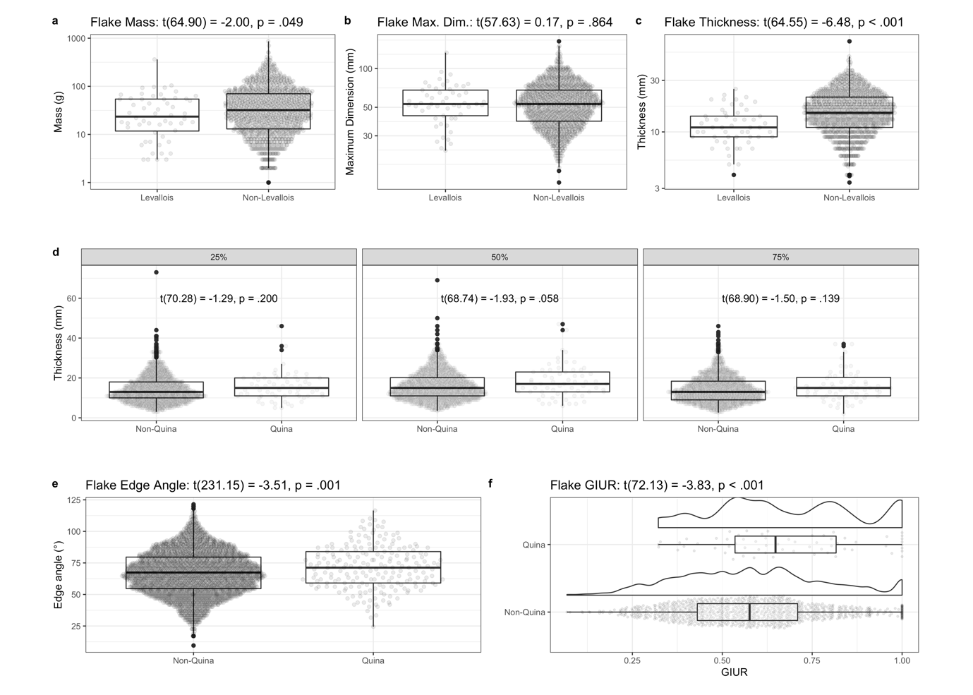

# **Figure 1 | Comparison of Levallois flakes vs non-Levallois flakes and Quina tools vs non-Quina tools.** (A – C) Histograms showing comparison between Levallois flakes and non-Levallois flakes on mass, maximum dimension and thickness at 50% of maximum dimension. (D) Histograms showing comparison of thickness distributions between Quina and non-Quina tools at different locations on the flake (25%, 50% and 75% at maximum dimension). (E) Histogram of edge angles between Quina and non-Quina tools. (F) Histograms of GIUR of Quina and non-Quina tools, also showing a density line to reveal the details of the distribution of GIUR values.

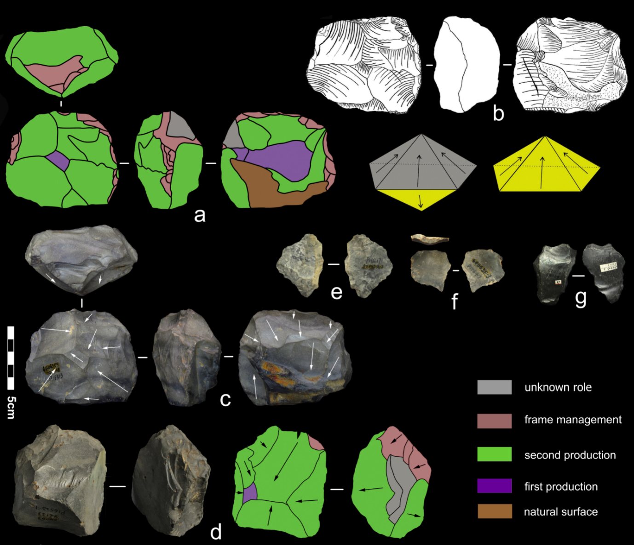

# **Figure 2 | Discoid cores and flakes.** (a-c): scheme, sketch and photo of a discoid core, the white arrows show the directions of removals. The core is formed by two surfaces, with radioactive recurrent scars from two production phases left on each surface (one surface is complete peripheral exploitation and the other is partial peripheral exploitation). (d): photo and scheme of another discoid core. The black arrows show the directions of the centripetal removals on the debitage surface. The other surface is minimally exploited. (e-f): pseudo Levallois point. (g): triangle flake with a main triangular scar covers the dorsal surface. Schematic model sketch shows two types of discoidal reduction patterns.

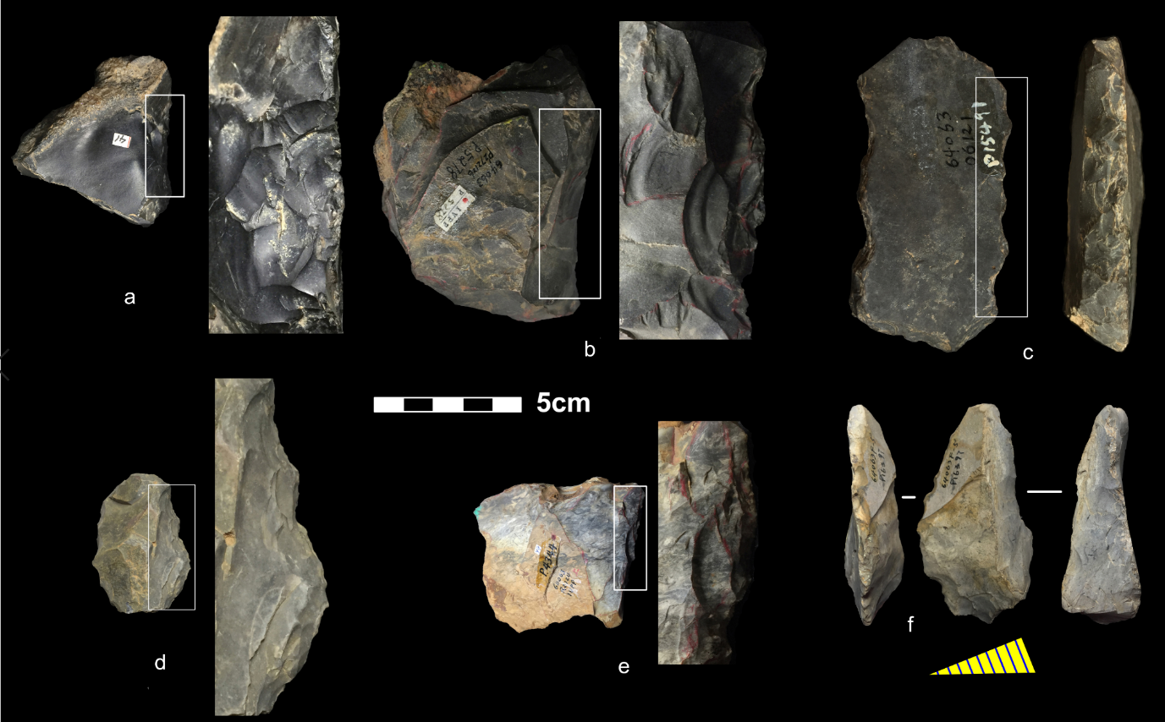

# **Figure 3 | Quina tools and retouched blank.** (a-e): Quina scrapers with stepped retouching scars that obtained from several phases of retouching. The white boxes on each tool edge show the areas of which the zoomed details on the right. (f): a blank, possibly achieved from Quina reduction, and then was retouched into scraper, the yellow oblique triangle below is the cross-section of the blank.

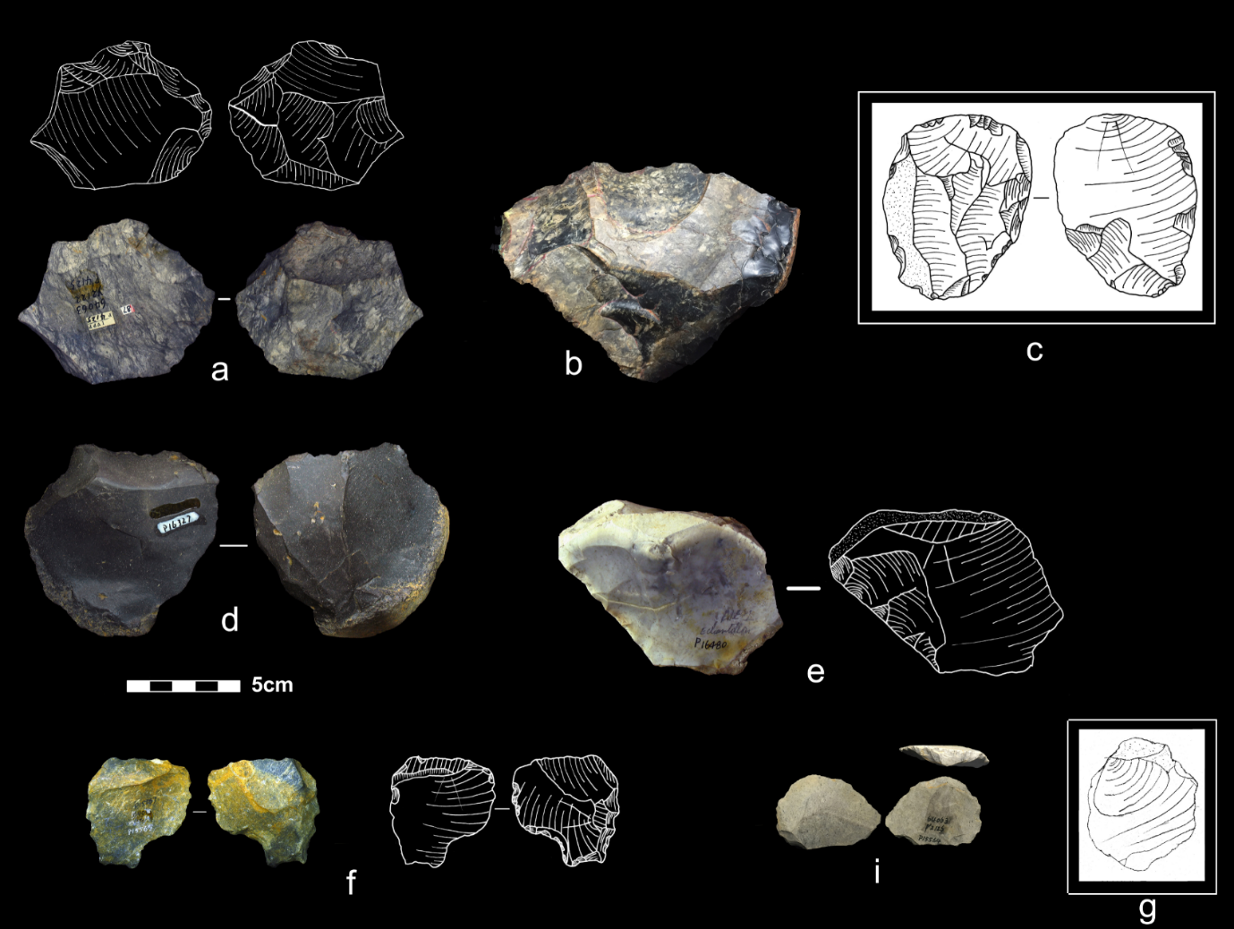

# **Figure 4 | Core-on-flakes cores and flakes.** (a-c,e): truncated faceted pieces with flake scars left on the ventral side of the origin flake. (d,g): Kombewa cores with the proximal end being detached. (f,i): Kombewa flakes consist of two ventral surfaces.

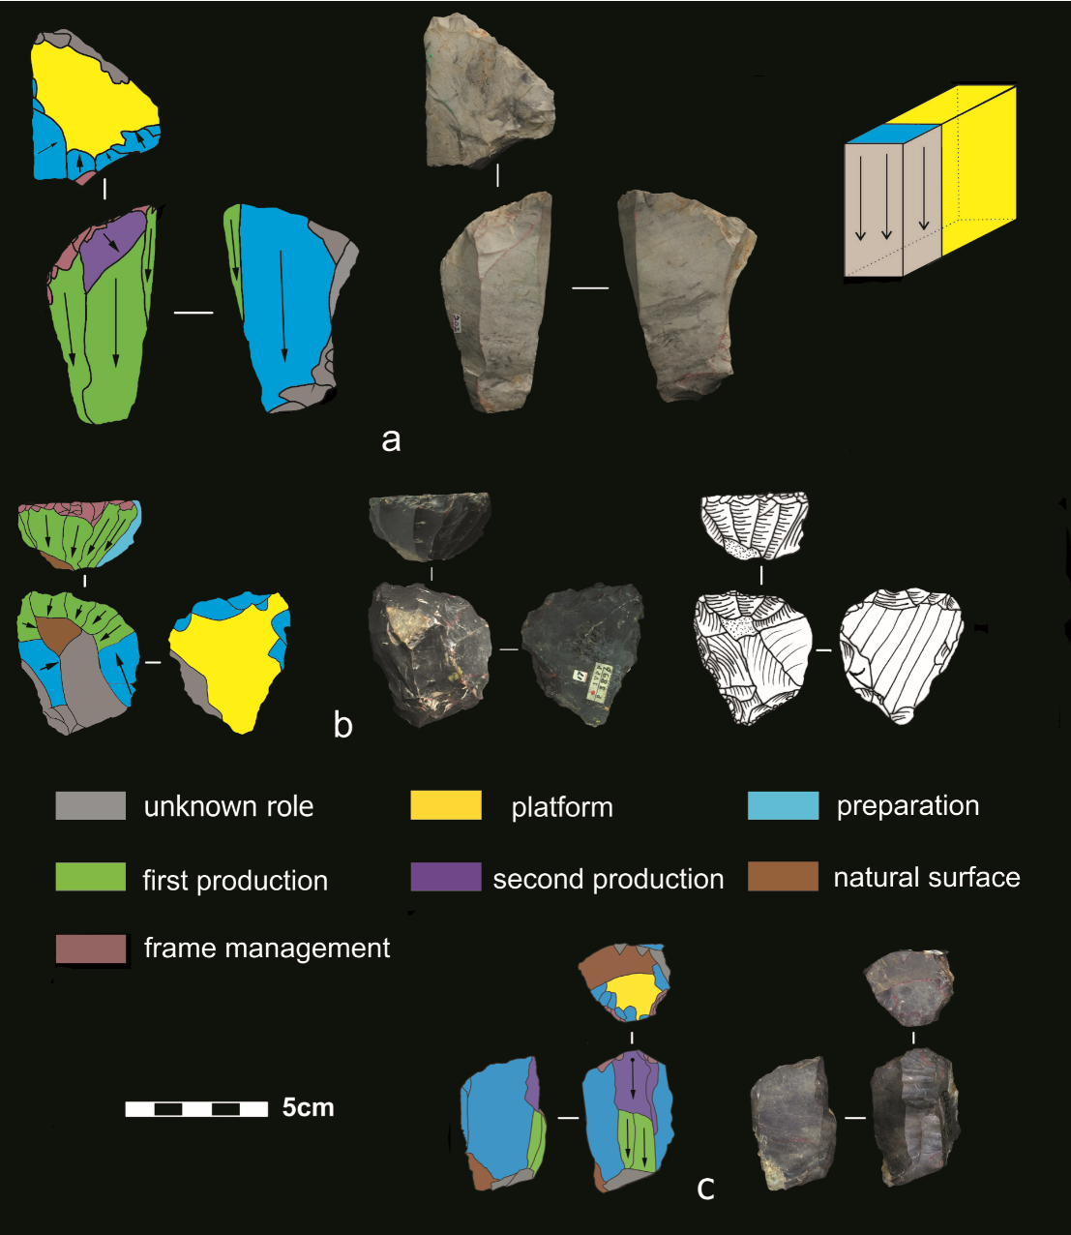

# **Figure 5 | Volumetric cores.** (a): scheme and photo of a volumetric core, from which 3 object products are detached. The platform of striking area is prepared and the lateral part of the volume is removed in order to preparing the flaking surface. (b): scheme, photo and sketch of another volumetric core, from which successive end-products were achieved. Platform of the end products are prepared. Lateral parts of flaking surface are removed in order to narrow the flaking surface. (c): scheme and photo of another volumetric core. The black arrows with black circle show the directions and impacts of removals. The volume reduction has two phases. The first reduction was successful, yielding two oriented products, while the subsequent reduction failed but took away the proximal of previous removals. Striking platform and lateral of flaking surface is somewhat prepared Schematic model sketch shows the reduction patterns of volumetric cores.